A Capstone Project Entitled

**ePahiram-(Micro Loans)**

*System Documentation*

Presented & Developed By:

Coligado, John Jason M.

Pandanan, Jhansept Kylo

April 2023

**Table of Contents**

**Title Page**

Table of Contents………………………………………………………………………………2

Introduction.....................................................................................................................3

Project Description…………………………………………………………………………….4

Project Scope.........................………………………………………………………………..4

Functional Requirements.....................................................................................5

Project Limitation.............................................................................................................5

Entity Relationship Diagram...........................................................................................6

System Flowchart............................................................................................................7

Wireframes.......................................................................................................................8

System Architecture........................................................................................................9

Tools & Frameworks..............................................................................................9

Packages..............................................................................................................0

Expected Acceptance Criteria...................................................................................10

User Guide......................................................................................................................11

Maintenance.................................................................................................................12

**Introduction**

This Business Requirements Document (BRD) outlines the requirements for the Loan Management Application (ePahiram loan flatform). Loan Management Application (ePahiram loan flatform) is a must-have tool for financial institutions and lenders aiming to streamline loan processing, cut costs, and boost operational efficiency. Lenders can focus on growing their loan portfolios and offering better customer care to their borrowers by employing this technology.

**Project Description**

Requirements includes developing Services and Admin application (Web) for the Loan management Application (ePahiram loan platform).

**Project Scope/Requirements**

The proposed solution is to create a loan management system that will streamline the loan application process, provide unique perks and facts about the offered loan, and enable customers to track the progress of their application. The loan calculator will also be incorporated, which will enable customers to estimate the total cost of the loan. This system will ensure transparency, provide a seamless experience for customers, and increase customer satisfaction.

The following areas are in the scope for this project:

**Web Services (Web API)**

* Jwt Token
* Gadget Loan (CRUD)

**User Application (Web)**

* **Login/Logout**
* Registration/Sign in
* **Manage Loans**
* View Gadget Loan
* View Gadget loan descriptions
* Payment Term
* Interest
* Requirements
* Application for Loan
* My Purchase
* Current Status of the Application
* Withdraw Application
* Manage Profile
* Update Password
* Loan Calculator (Optional)

**Admin Application (Web)**

* **Login/Logout**
* Profile
* Change password
* **Dashboard**
* Pending Loan Application
* Non-Active Loan Application (Withdraw & Declined)
* **Manage Users**
* READ / DELETE
* **Manage Gadget Loan**
* Create Loan
* Read Loan
* Update Loan Details
* Delete Loan

**Functional Requirements**

The requirements in this document are divided into the following categories:

**System Requirement**

|  |  |  |
| --- | --- | --- |
| **Item** | **Rating** | **Description** |
| Login/Registration/ Logout | High | User will be able to login with their provisioned account details. Also, able to register new accounts. |
| Dashboard for user and admin | High | * Dashboard for user, to view the given loans and requirements * Dashboard for admin, to view purchases of the loan * Manage Application Status (Admin) |
| Purchases | High | List all Existing and archived purchases of the loan(admin) |
| My Purchase | High | List all the details for purchase (User) existing and archived |
| Gadget Loan | High | Provide list of terms, interest, and available gadgets for loan. Also, payment computation for the chosen entity. |
| Account Roles | High | -User must perform the indicated features for purchase, compute loan and views gadget loans. -Admin has the privilege to add Gadget Loan, update details, delete, view purchases history, and manage users |
| Loan Calculator | Low | Provide requirements and details for the loan (extra features) |

**Rest API**

|  |  |  |
| --- | --- | --- |
| **Item** | Rating | Description |
| Authentication | High | User will be able to login with his provisioned account details. |
| Gadget Loan Crud | High | API’s to access the database of the gadget loan and manage it using CRUD operation. |

**Non-Functional Requirements**

|  |  |  |
| --- | --- | --- |
| **Item** | Rating | Description |
| Payment option | Low | Over the counter payment, online banking, and cash payment on remittances |
| Inventory Management | Low | List of available gadgets for loaning use for tracking availability. |

Currently, Native software is used, which contains only static information about loan details, eligibility, and conditions. Proposed solution to produce and manage loan applications, with unique perks and facts about the offered loan, as well as an innovative loan request response that shows the progress of the loan application and a loan calculator.

**Project Limitations**

The following areas are out of scope for this project:

* Integrating with external third-party payment tools for managing the payment options for the loan applicant like, any online banking, over the counter payment, and remittances center.
* inventory management for the remaining quantities and availability of the gadgets inside the gadget loan.

These items are also mentioned in non-functional requirements of the system. Also, the areas above are subject to future enhancement of the system, these areas may be implemented by future developers who are interested integrating this area as additional features of this system.

**Wireframes**

Attached below are the mock up design of the system interface and reference to the system requirements:

**Landing Page**

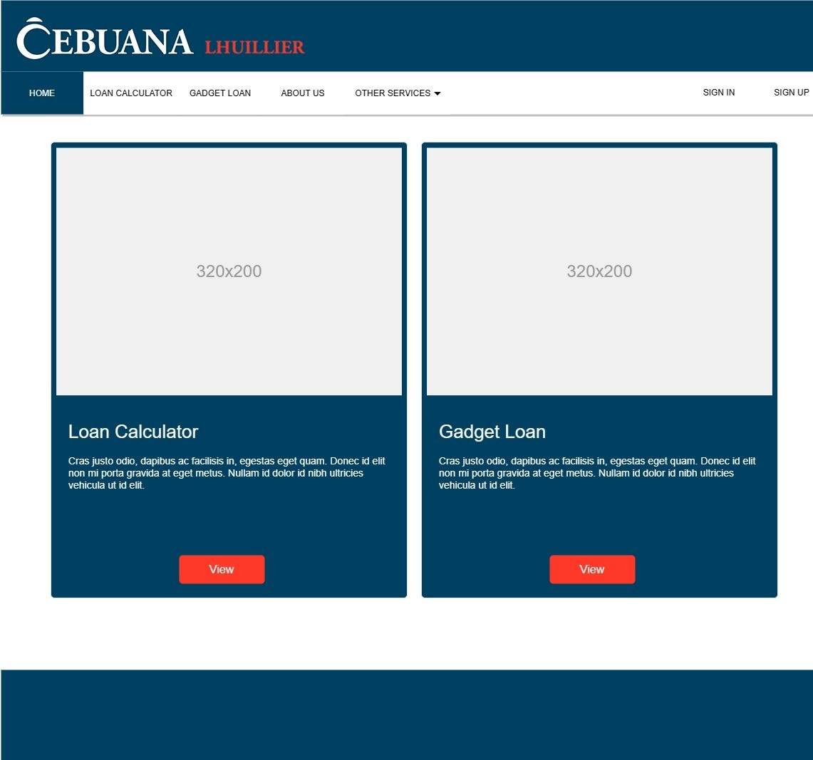

**Sign In Page**

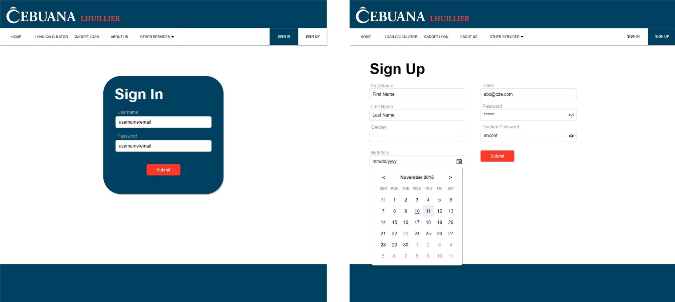

**Sign Up Page**

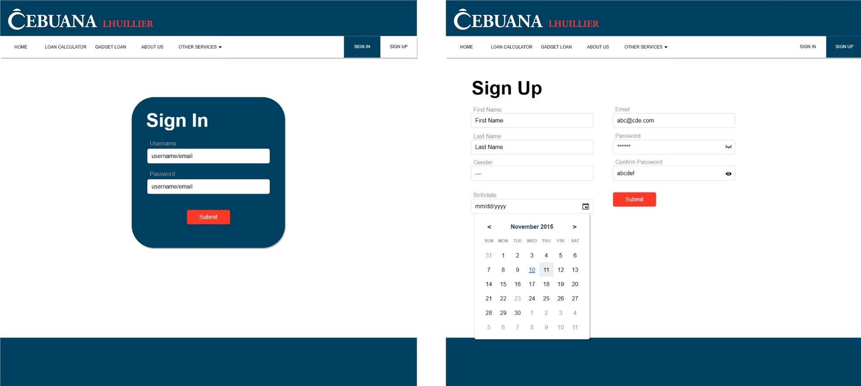

**Gadget Loan**

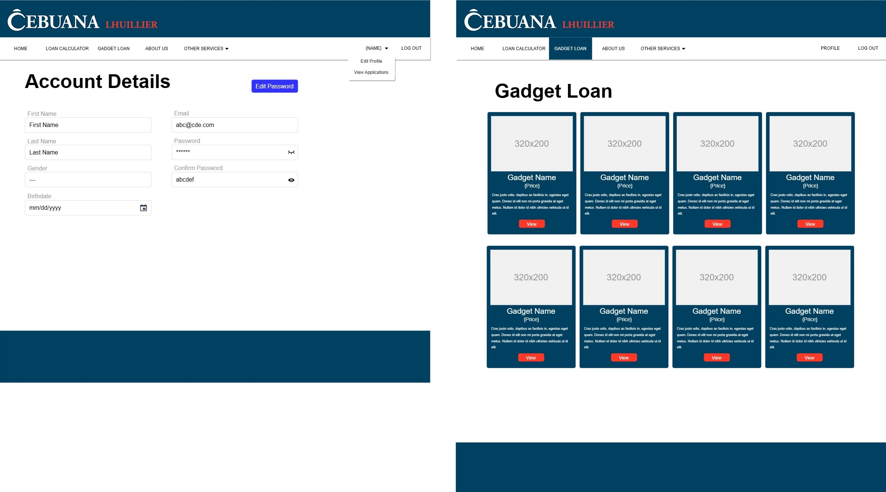

**Account Details**



**Gadget Loan**

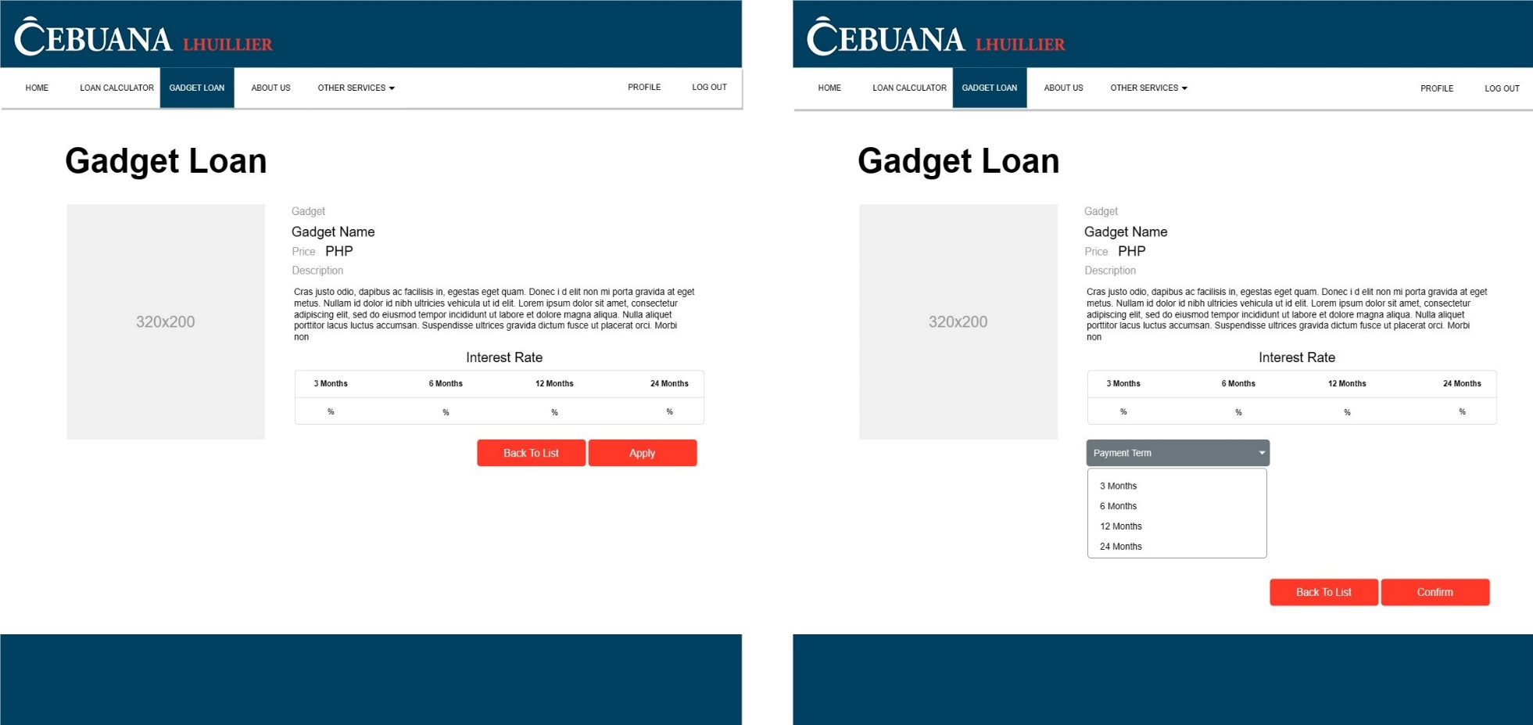

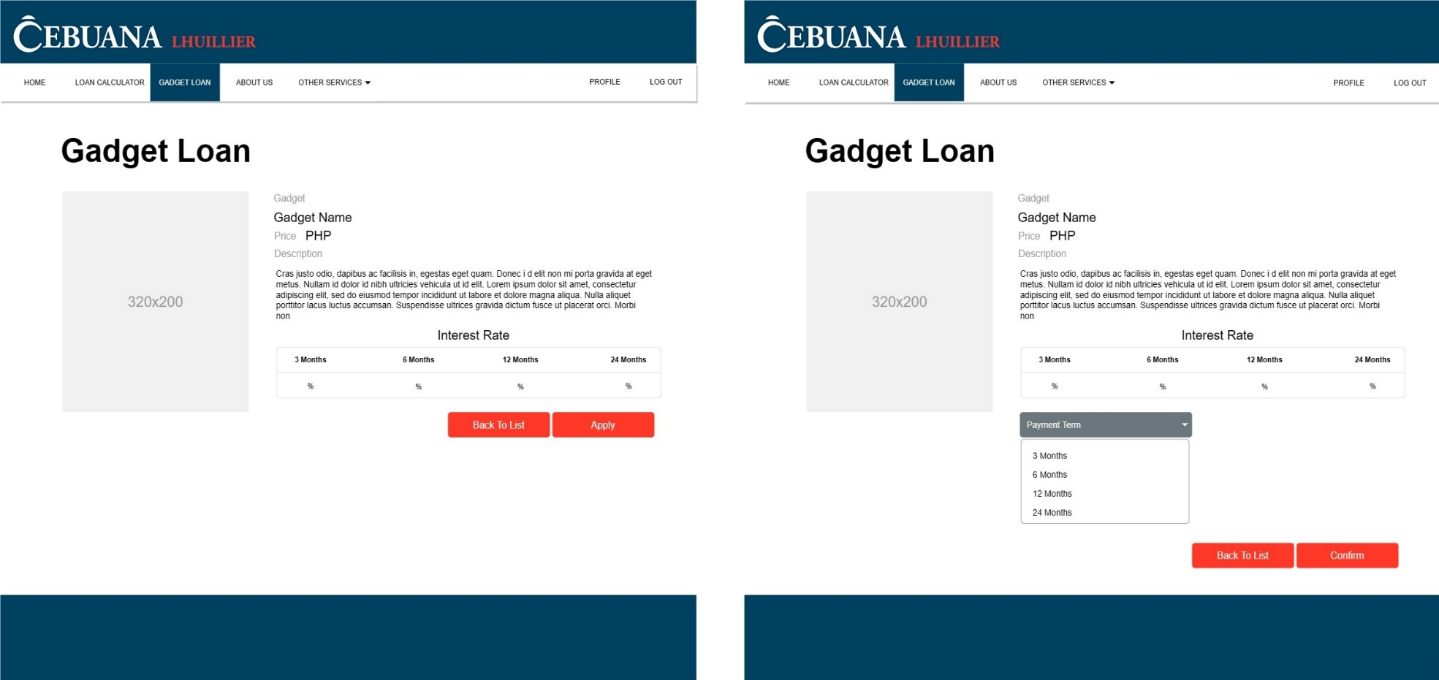

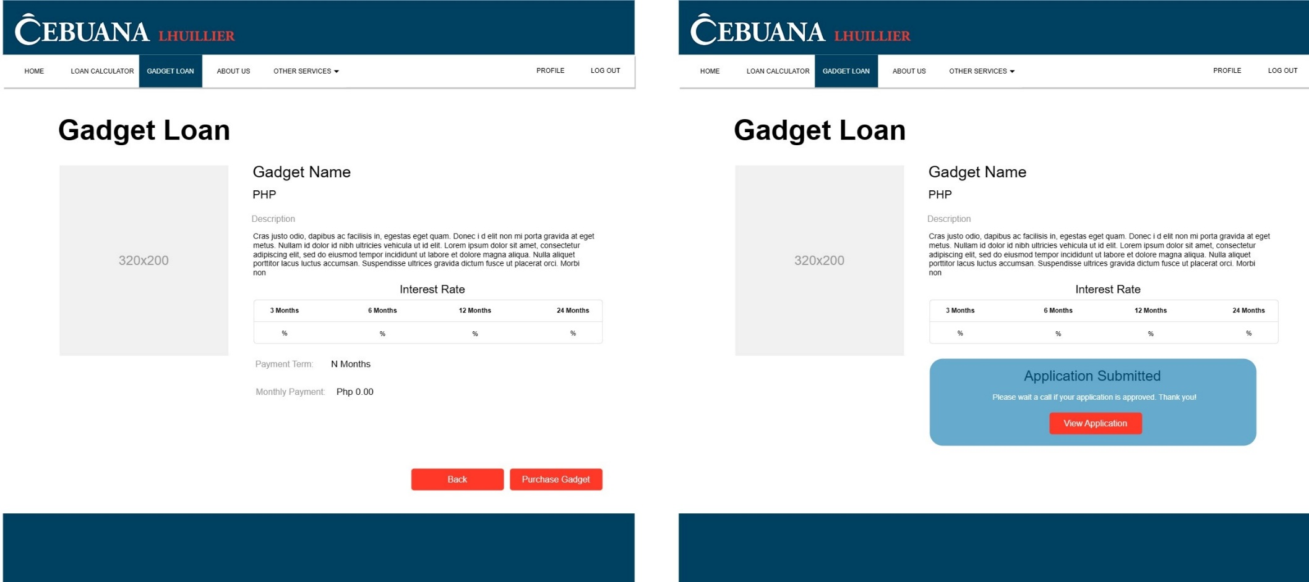

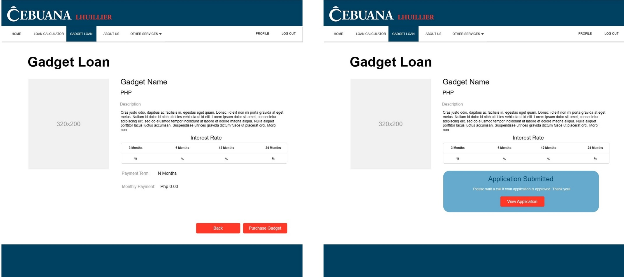

**Loan Calculator**

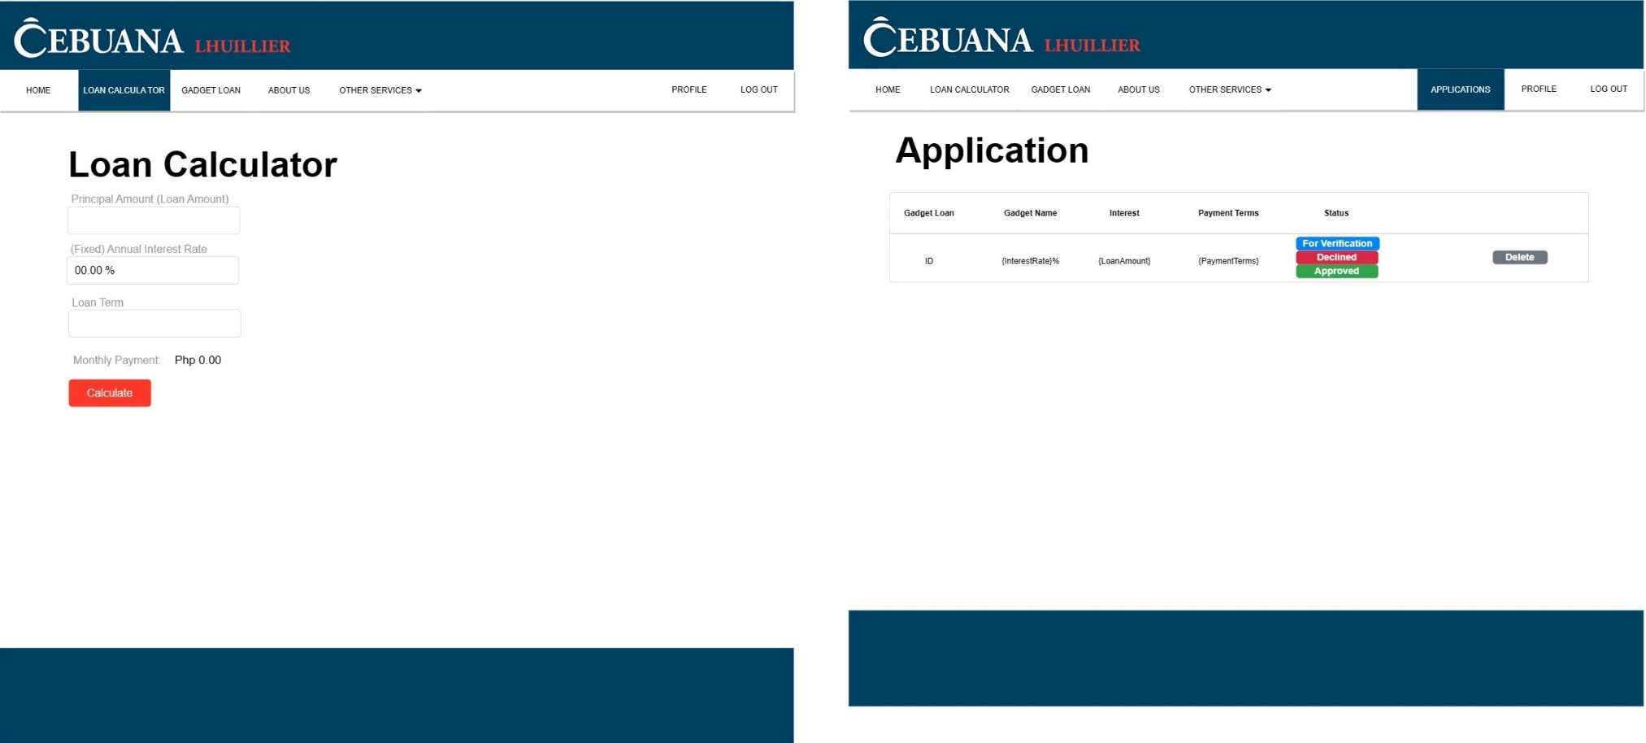

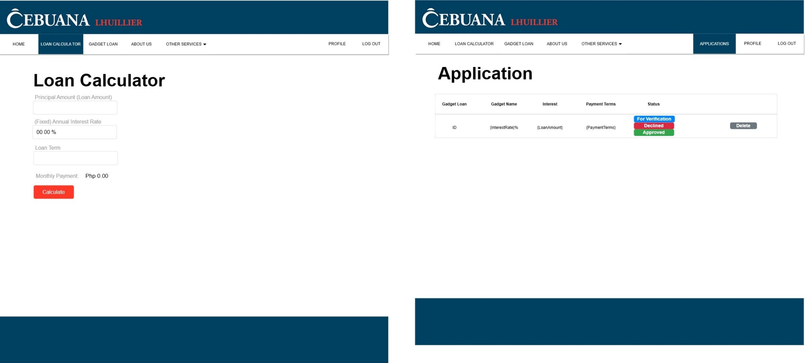

**Administrator Side**

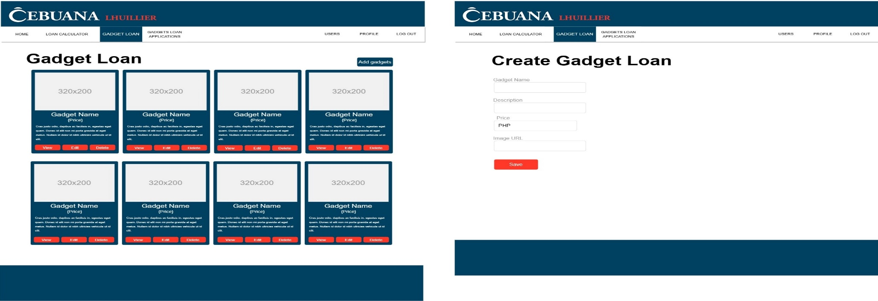

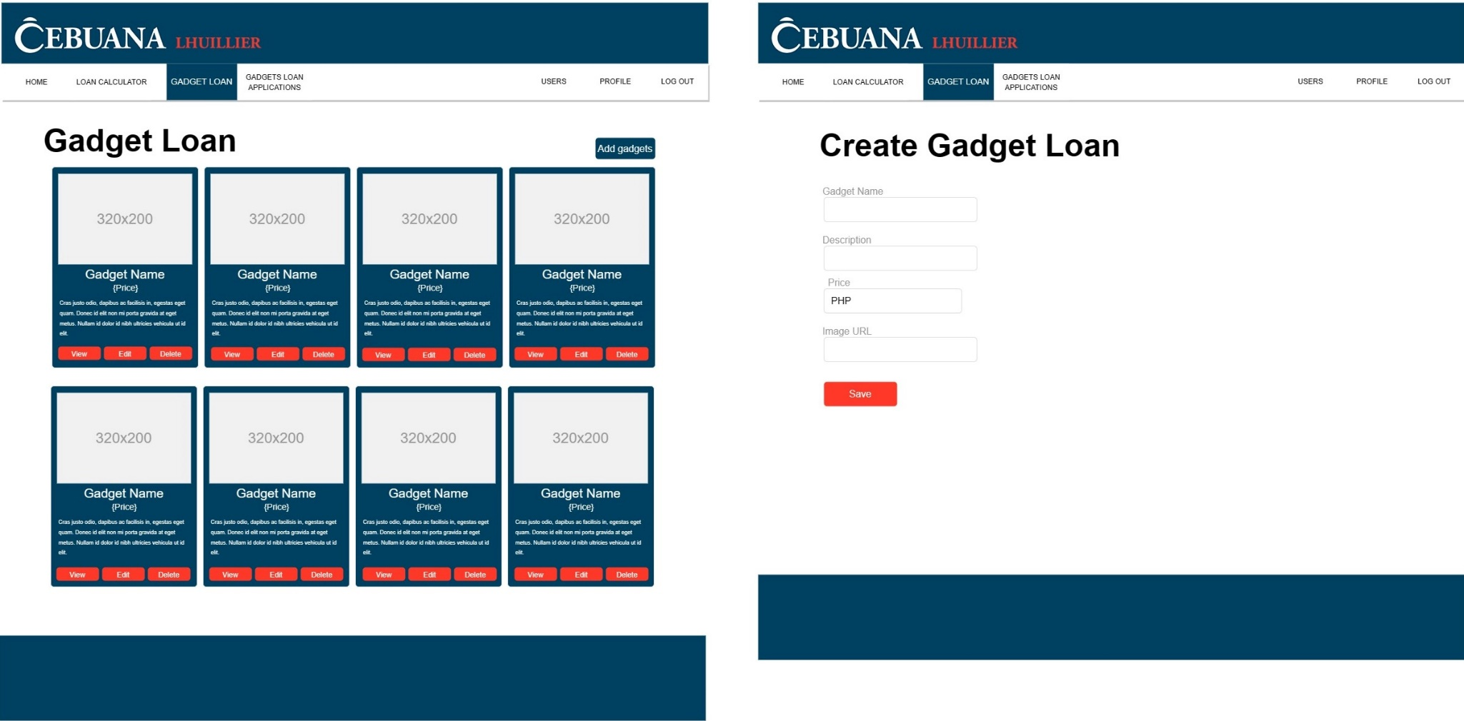

**Manage Purchases**



